Creating Advanced Charts

**Creating Treemaps, Scatter Charts, and Histograms**

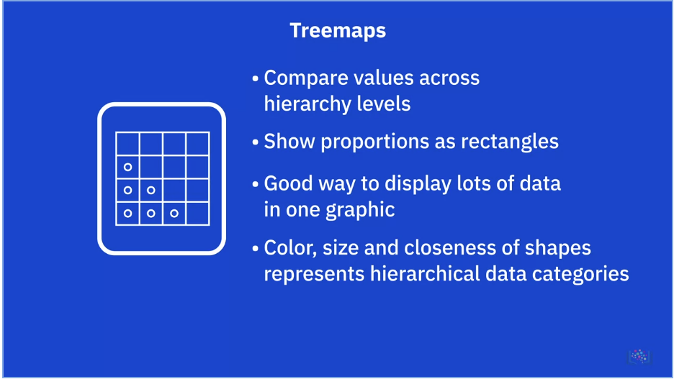

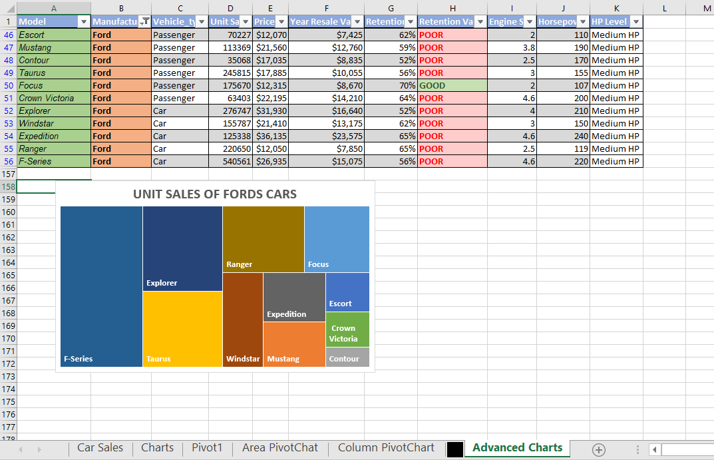

* We use Car_Sales Workbook, Treemaps Worksheet
* Step 1: Sort the model to “Ford” only
* Step 2: Select the columns of “Model” and “Unit Sales” only
* Step 3: Insert tab > Charts group > Insert Hierarchy Chart > Treemap

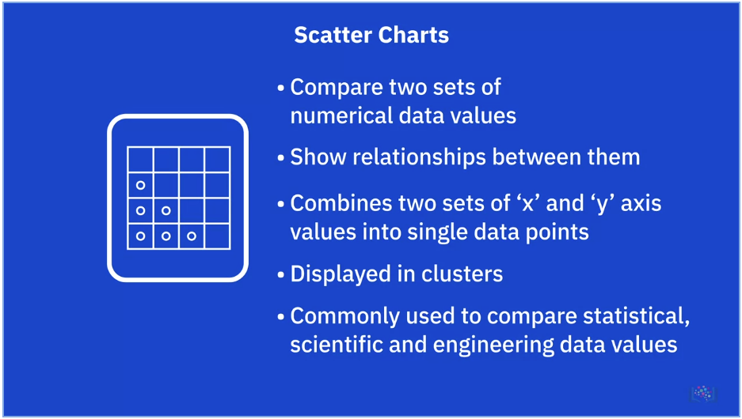

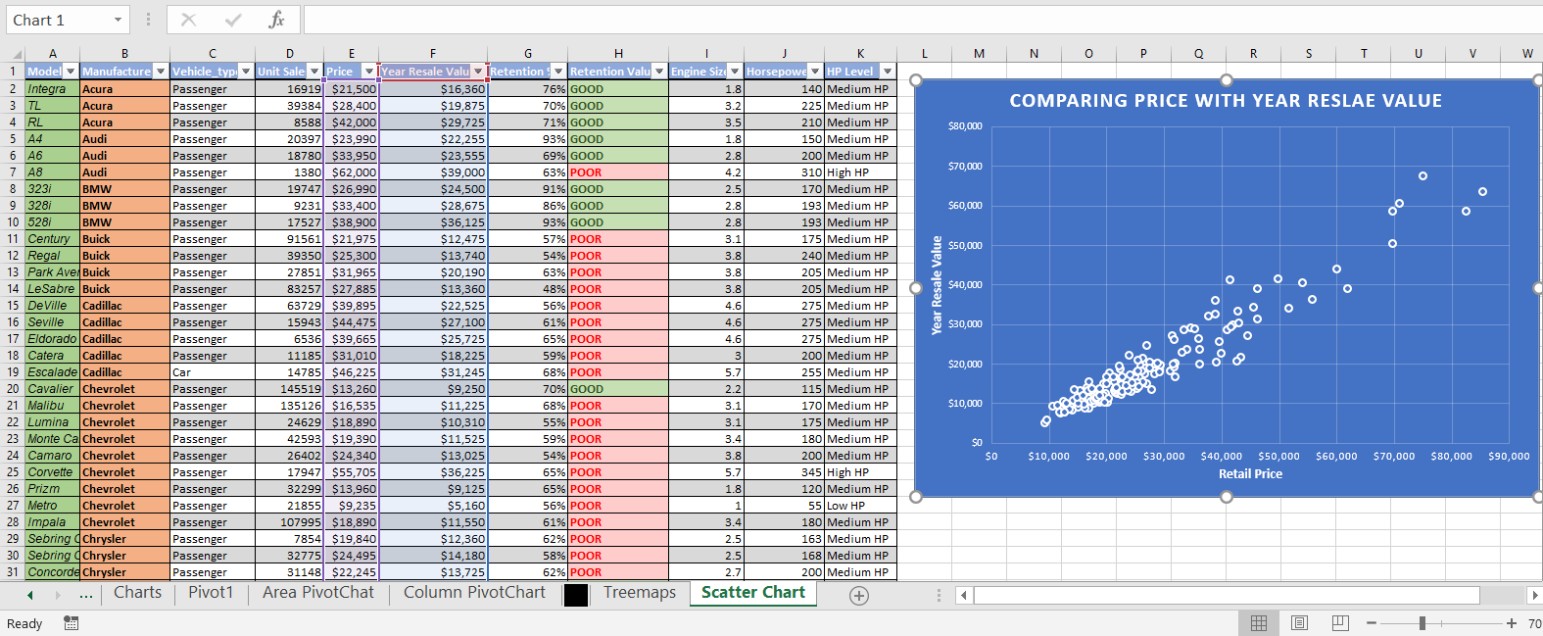

* We use Car_Sales Workbook, Scatter Chart Worksheet
* Step 1: Select the columns of “Price” and “Year Resale Value”
* Step 2: Insert tab > Charts group > Insert Scatter (X, Y) or Bubble Chart > Scatter

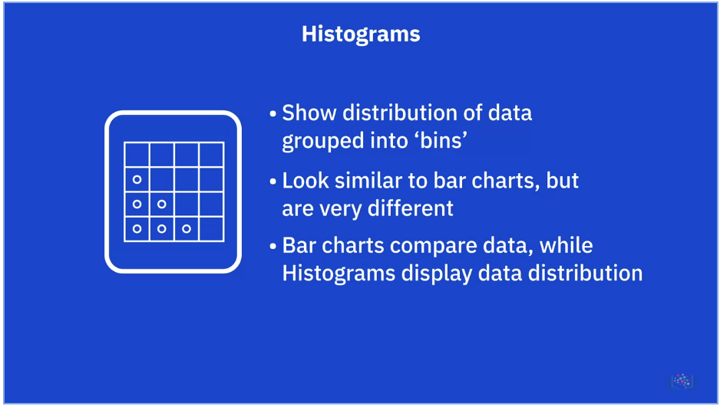

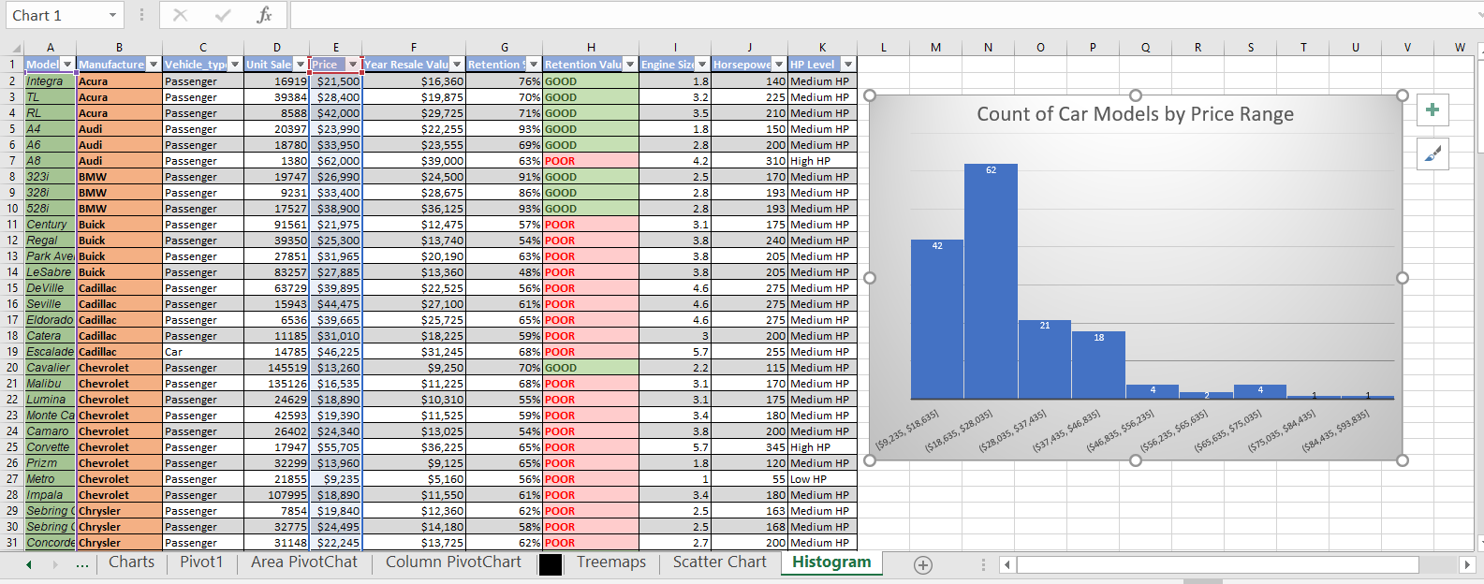

* We use Car_Sales Workbook, Histogram Worksheet
* Step 1: Select the columns of “Model” and “Price”
* Step 2: Insert tab > Charts group > Insert Statistic Chart > Histogram
* To change the bin width / number of bin, double click on horizontal axis > Axis Options tab > Axis Options > Bin width / Number of bins

**Creating Filled Map Charts and Sparklines**

Filled Maps:

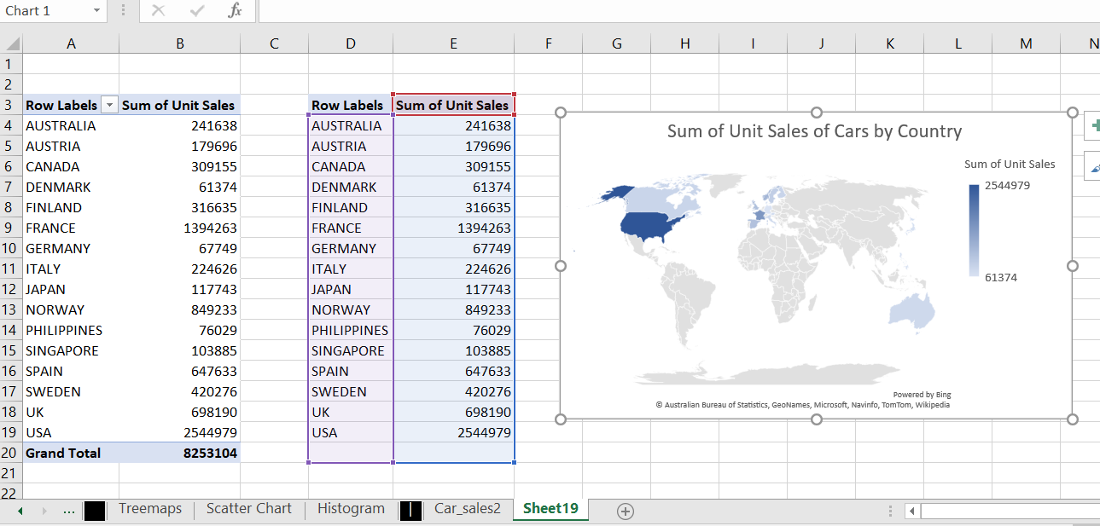

* We use Car_Sales Workbook and Car_sales2 + Filled Map Worksheets
* Step 1: It not allowed to create a map in PivotChart, so we need to copy the data without Grand Total
* Step 2: Insert tab > Charts group > Maps > Filled Map

Sparklines:

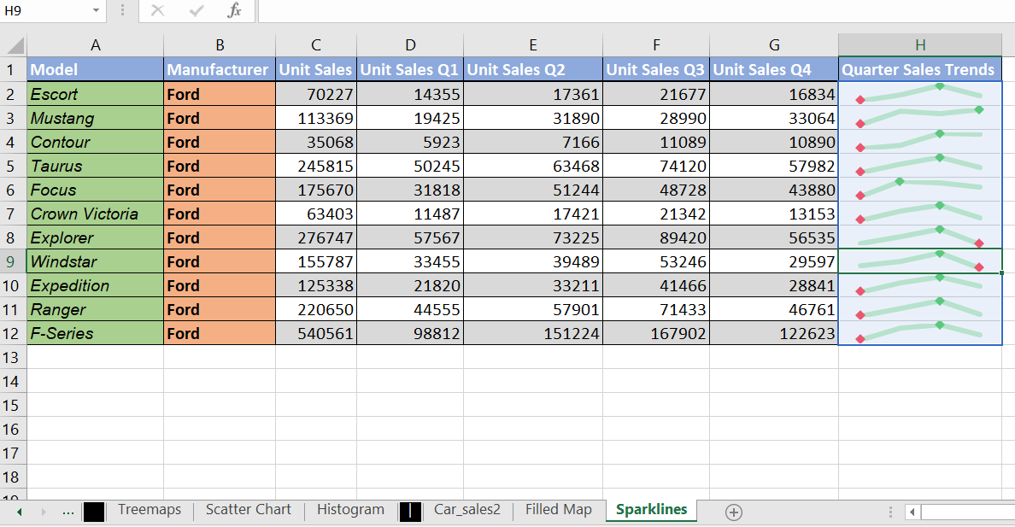

* We use Car_Sales Workbook and Sparklines Worksheets
* Step 1: Select the Q1 to Q4 (D2:G2)
* Step 2: Insert tab > Sparklines group > Lines
* Step 3: Location range just put beside of the Cell G2
* Step 4: Drag the fill handle
* On the Design of Sparkline Tools tab > Show group > check the High Point & Low Point
* Also can adjust the weight of the lines > Sparkline Color > Weight > 3 pt

Sunburst:

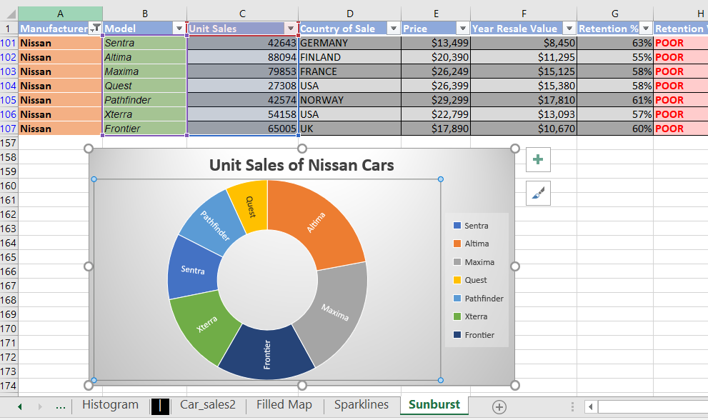

* We use Car_Sales Workbook, Sunburst Worksheet
* Step 1: Filter the Manufacturer to “Nissan” only
* Step 2: Select the columns of “Model” and “Unit Sales”
* Step 3: Insert tab > Charts group > Insert Hierarchy Chart > Sunburst